MOOR NEWS
Moor's Edge u3a Summer Newsletter.

Your summer Newsletter has been put together from the information supplied by committee members along with a piece by a Moor’s Edge member. We welcome any articles that you consider of interest to other members. The next Newsletter will be the winter one in Nov/Dec.

Summer tea Tuesday 1st July at the Crown Plaza, Marco Pierre White Suite 1.30 for 2pm.

There are 4 places left for this afternoon tea.
We have opened the event to non-members due to the low take up.
If you want one of the remaining places, then please book it with money at the next general meeting on Friday 13th. This will be the last time before the event.
Details are also on the web site: -
https://moorsedge.u3asite.uk/u3a_notices/summer-afternoon-tea/  Terry Lane.



Hello there. Ruth here. I wonder if anybody in Moors Edge knits? The situation in Ukraine is still deteriorating - more displacement v shelters being set up. Shelters for the elderly, for autistic children. For the disabled then orphanages brutal places with facilities for 350 at a time. There is growing need for blankets made from eighty knitted squares each square six inches across. We need camouflage blankets for the guys in the front line using three colours only :- black, very DK green & very DK brown. Then children need the warmth & security a blanket needs. We pack up a child’s blanket with a knitted teddy or suchlike. There is a big storage unit on my drive (black lid) box inside for granny squares. Please leave your name & mobile number with any granny squares you can donate. PUMA have a target:/ to produce 100 000 granny squares in 2025!
I feel sure we will smash it! Please help. A million thanks.
Using needles size 7/ metric 4.5 And double knitting wool, cast on 32 stitches. Knit garter stitch for 40 rows. Cast off.
Those children do not deserve to be traumatised. Can we at least offer a warm blanket?
Ruth Jordan Mobile 07975 898 013

SPEAKERS.

13/06/25 Matt Cole
Matt has been a regular contributor to Plymouth Links Magazine writing about the life on Greenwell Farm and the challenges of being a Dartmoor Farmer. He will recount some of his many experiences for us in his talk.

11/07/25 Mick from Six Bees
Mick is head Beekeeper at local honey producers, Six Bees, and will be bringing with him an observational hive so that we can see the inner workings of a beehive. As well, I am sure as having plenty of jars of Six Bees honey for us to purchase.

10/10/2025 Devon Freewheelers Blood Bikes
The Devon Freewheelers Bike service offers a FREE courier and transport service to NHS establishments, medical surgeries, air ambulances and the community across the South West. The service costs over £200,000 per year to run and is reliant on public donations.

14/11/2025 Ian Gasper
Ian is a former head teacher and much travelled individual who has volunteered with V.S.O. twice. He is currently Chair of Devon and Cornwall Refugee Support. He will be talking about his travels in Patagonia covering history, landscapes wildlife. So, something for everyone!

Chris Dally. Speakers.

WOOLWELL SUMMER FAIR

We have a table to promote Moors edge U3a at the Woolwell Summer Fete on 19th July
Between 12pm to 4pm please come along and bring your friends, we will be selling a few craft items to raise money for our club.

Sue Hampson-Ellis.

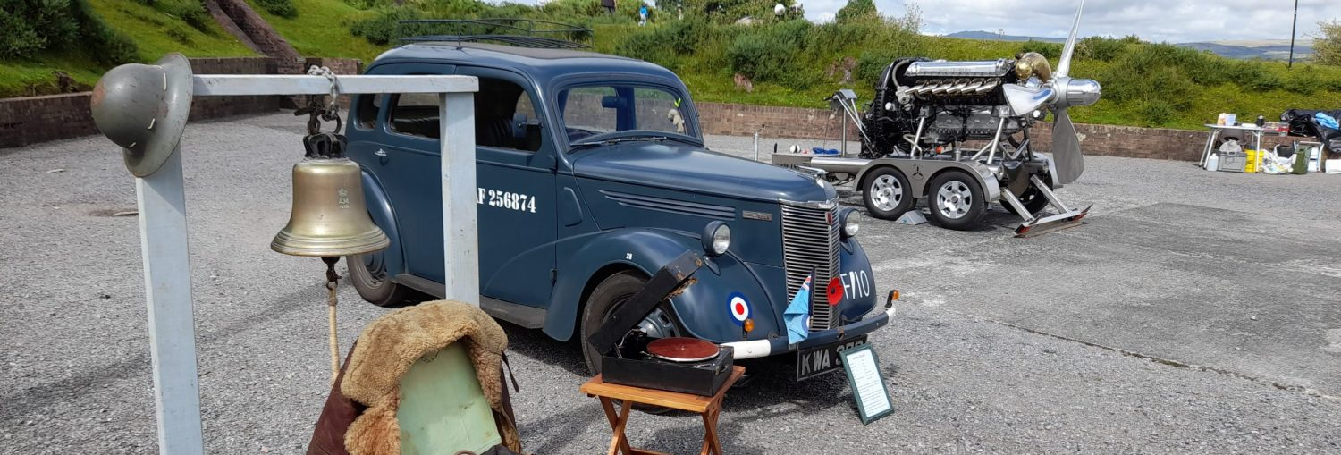

RAF Harrowbeer 1940s Weekend 16th and 17th August 2025.

Moor’s Edge u3a have arranged to have a stall on the airfield at the RAF Harrowbeer 1940s weekend. We are hoping to attract some new members. We will be giving out leaflets and talking to people about the u3a and the group activities, social activities and friendship groups on offer.
Some members have already offered to spend a couple of hours on the stall, but the more volunteers we have the easier it is for all. There will be an opportunity for you to sign up to help at the next general meeting. It should be a fun weekend.

Terry

PLYMOUTH SYNAGOGUE Thursday 11th September.


It is proposed that we make a 2nd visit to Plymouth Synagogue as those who went last time found it so informative and enjoyable that they wanted to go back to hear and see more of the Synagogue and it’s history. This time we will have what they call the 2nd informative talk covering different aspects from last time and also a visit to the Jewish Cemetery. There will be a board out at the next and following general meetings for you to put your names down.

September General Meeting Friday 12th September.

The September general meeting, in addition to being the 11th anniversary of Moor’s Edge u3a, will also be a recruitment fair. Group leaders and group members have been asked to share the activities of the group, whether it is a walking group, a book group, a music group or one of our many other exciting activities. Bring some friends with you. Browse the groups on offer. Enjoy a cup of tea and a biscuit. Take this opportunity to increase our membership. I look forward to seeing lots of old and new faces.
Terry Lane.
p.s. If you can let any committee member know if you can come along with a friend, neighbour or relative it would help us in knowing how many people to cater for with refreshments. Thanks.

New Year Meal

Although this is a long way off, we need to make a provisional reservation by July.
Would members prefer to go to Yelverton Gold Club, a firm favourite previously? We understand things have improved there, so hopefully back to being as good as it was before. Or Elizabeth House, where we held the last New Year Lunch. If you have a preference, once again please let any committee member know, or email Sue Hampson-Ellis suehampsoes@gmail.com

Committee.
Chairman Terry Lane Vice Chair Sue Britten
Treasurer Ginny Harvey Secretary Eileen Lane
Membership Maureen Maskell Speakers Chris Dally
Publicity Sue Hampson Ellis Promotional Material Carmela Watson
Group Coordinator Sue Britten Webmaster Ginny Harvey
Committee Kate Tasker& June Williams

Moors Edge u3a need members to think about if they
Join the committee.

Next year at our AGM in May, the Chair, Vice Chair, Secretary, Treasurer, and Web Master will all have served their term in office. All will have completed their 3-year term, some for far long. All these are vital roles which without them being filled we may longer have Moors Edge u3a.
Being on the committee does not have to be a huge time-consuming job, what is needed are people who are willing to help out both practically and join in with decision making. New Ideas from new people on the committee stops things becoming stale, which can only be a benefit to all members.
Any member who would like to come along and see what being a committee member is all about, would be welcome at any committee meeting, just let us know. Committee meetings are held at Woolwell on the last Thursday of the month, except December.
Sue Britten.

